Course Code: CSA1557

Course Name: Cloud Computing and Big Data Analytics

S.Prakul 192210073

3) Create a simple cloud software application for Car Booking Reservation System using any Cloud Service Provider to demonstrate SaaS include the necessary fields such as search for cabs, from, to, rental , out station, Package type, hours/Days etc.

AIM: To Create a simple cloud software application for Car Booking Reservation System using any Cloud Service Provider to demonstrate SaaS.

PROCEDURE:

step1: Go to zoho.com.

step 2: Log into the zoho.com.

step 3: Select one application step.

step4: Enter application name as Car Booking Reservation System.

step 5: Created new application as Car Booking Reservation System.

step 6: Select one form

step 7: The software has been created.

IMPLEMENTATION:

STEP1: GOTO ZOHO.COM

STEP1: GOTO ZOHO.COM

STEP 2: LOGINTOTHE ZOHO.COM

STEP 3: SELECT ONE APPLICATION

STEP 4: ENTER APPLICATION NAME

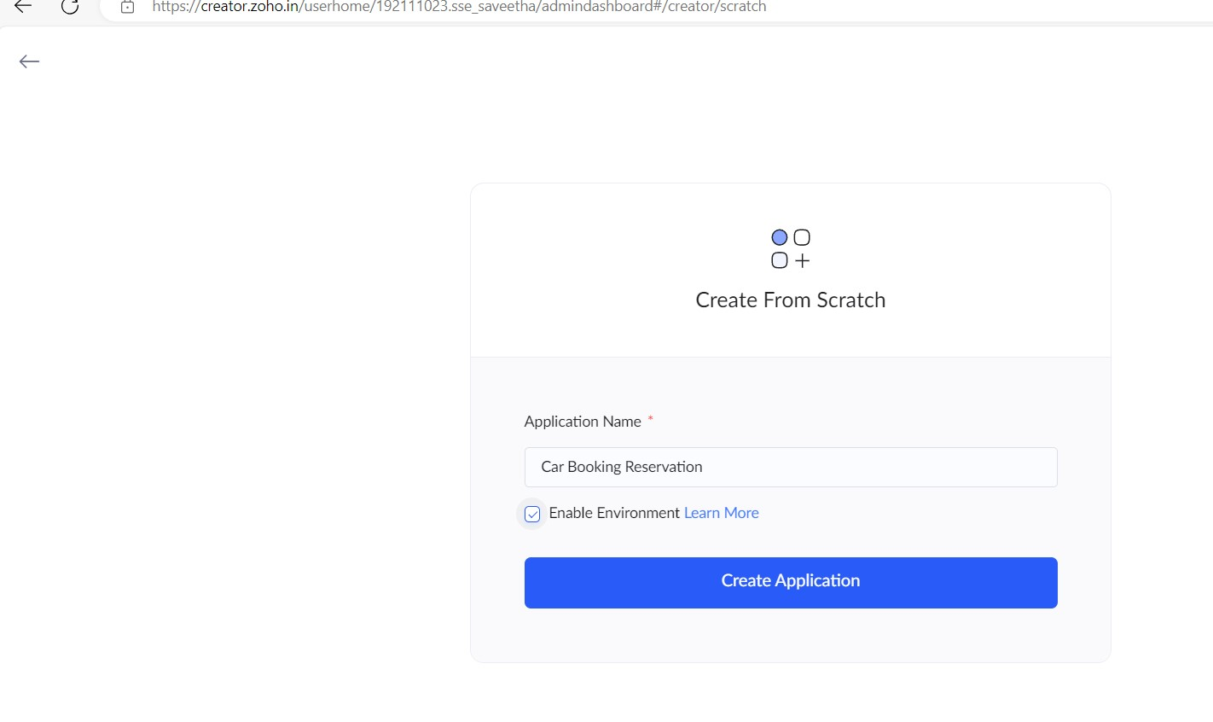

STEP 5: Created new Application

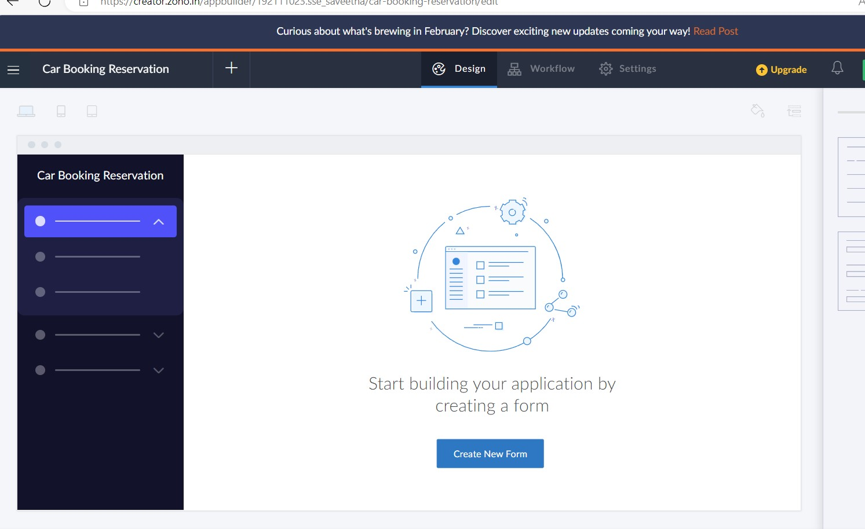

STEP 6: Select from Stratch and Create form as CabFinder.

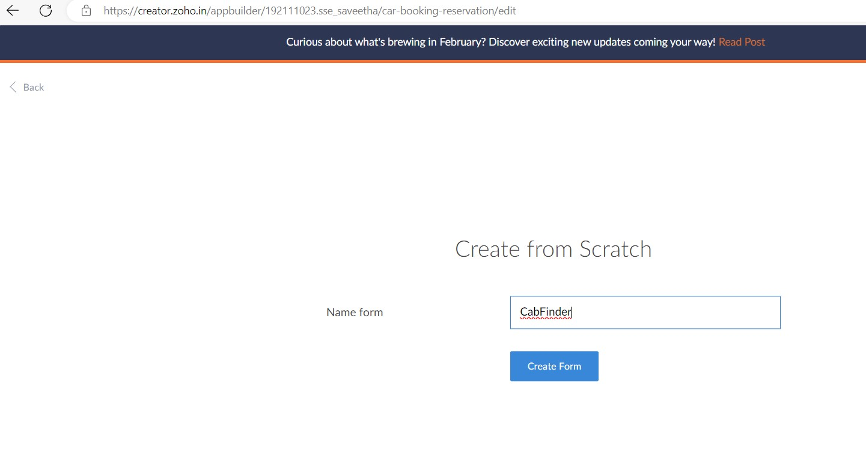

STEP 7: The form has been Created as CabFinder.Then choose the fields.

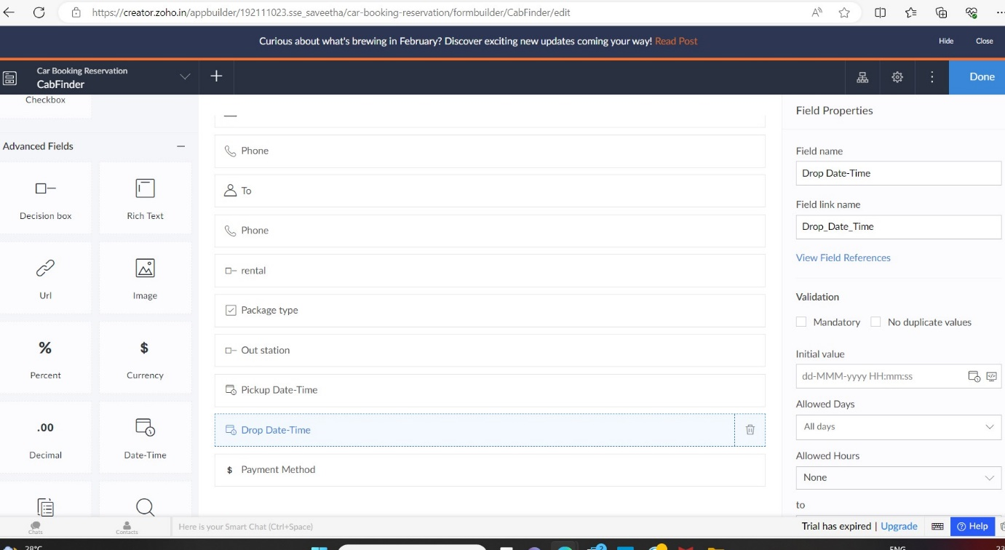

STEP 8: Click Access Development Live

STEP 9: Enter the details to register.

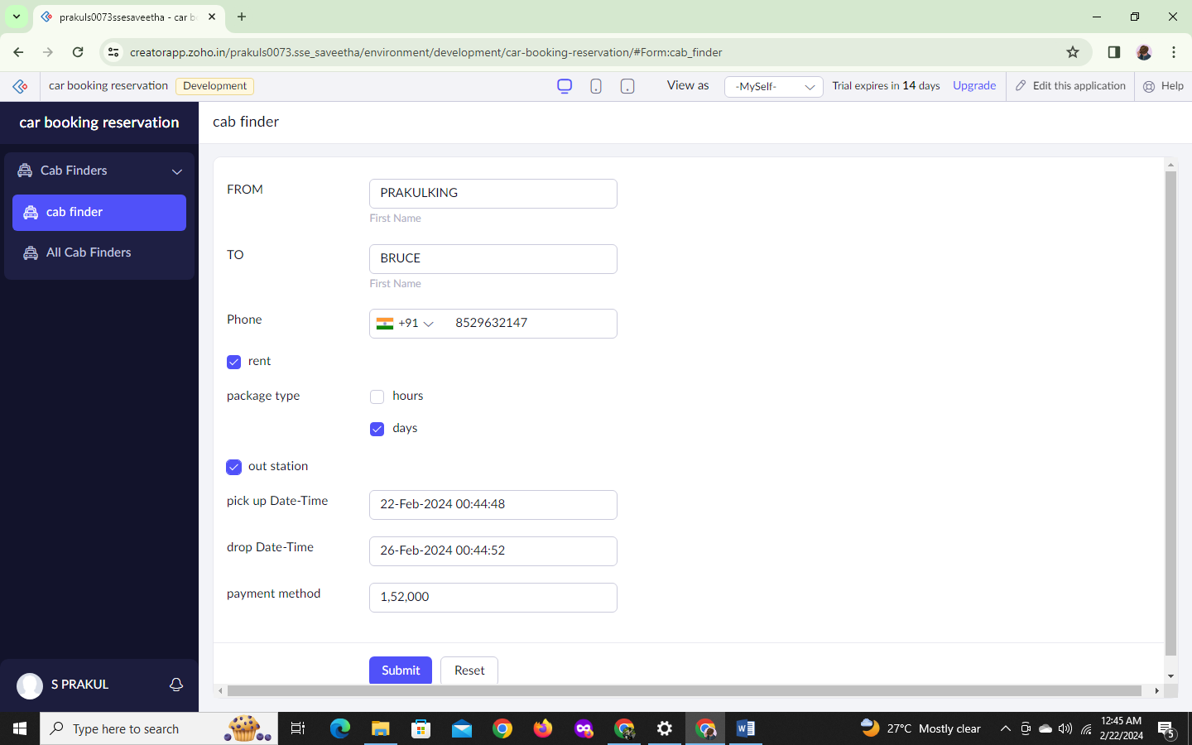

STEP 10: The report has been registered in the CabFinder report.

